SCM 651

Homework #3

Team 4: Phoebe Sheahan, Emilio Ramos Monzalvo, James Eakins, Shaun Hall, J.R. Slouffman

1. Regression analysis

a. Graph the percent purchased against price.

b. Perform a regression using power regression to determine the predicted %

column.

i. Graph the new curve.

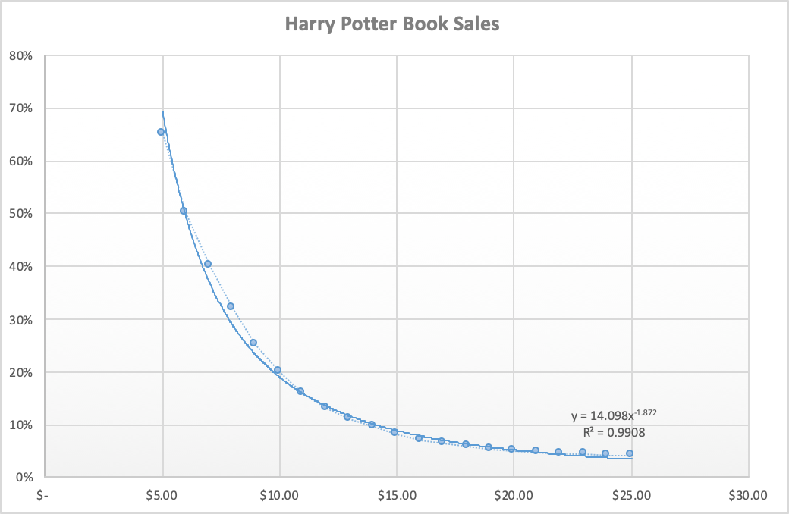

ii. Estimate the equation of the line.

The equation is **.**

iii. What does the R2 mean?

R2 is used to see how well the line fits the data. The closer the R2 value is to one, the better the y is explained by the x variable using the exponential fit.

For this regression curve R2 is .9908 which tells us that the regression equation is a good fit for the data predicted since it is very close to one. This can also be interpreted to mean that the correlation of the data between the predicted sales and price is accurate relative to the equation. Based on this graph Book Emporium would likely aim for predicted sales of 16% and price the book at around $10.00 per book. Based on the the optimization table this combination would give them an optimal profit ($95,021).

c. Assuming there are 100,000 customers who visit your website and the publisher cost is $5.00, estimate the number of books sold (predicted sales column)

d. Calculate the revenue column (price * predicted sales)

e. Calculate the profit column ((price – book cost) * predicted sales)

f. Use conditional formatting to highlight the profit values for all prices

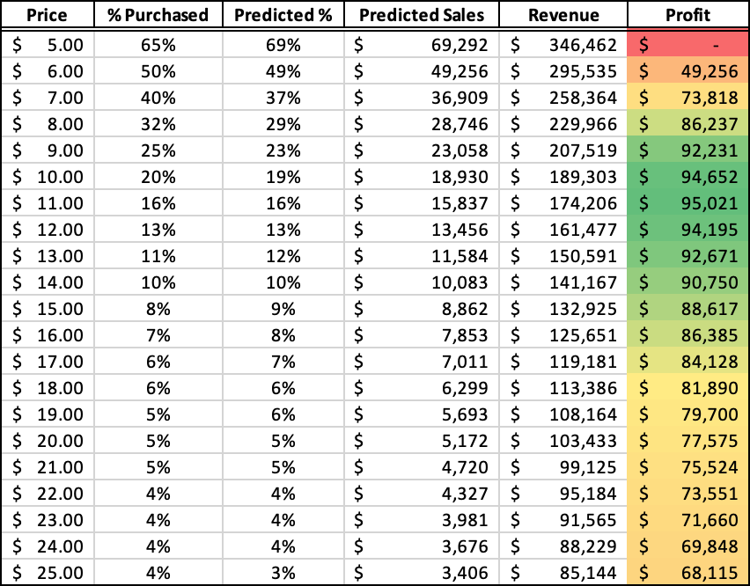

2. Optimization analysis (with constraints)

a. Calculate the price point for the highest profit possible

i. The publisher will sell the books to you at $5.00 each with no minimum order.

With the book cost 5.00 dollars and minimum order, if we sell the book for 10.73 cents, then the purchase rate will be 65% and predicted sales will be 16,580 dollars. The revenue will be 17,7965 and the profit will be $95,066.94, which is the highest profit that predicted by the excel function.This is similar to what we predicted from question one,in that we assumed between $10 and $11 for book cost, would generate the most profit from the book sales.

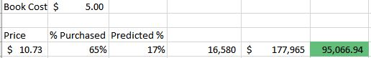

ii. The publisher has agreed to sell you the books at $4.50 each if you sell at least 30,000

For the book cost of 4.50 dollars, we will sell the book at 7.82 dollars.This price creates a higher predicted sales at 30 percent. At this price we have to sell at least 30,000 books which will create more revenue. We know this goal is attainable because there are predicted sales of 30% which is significantly higher than the 17% prediction if the book cost is set at $5.00. The total profit would be $99,586.50 if the book sells the same amount that has been predicted.

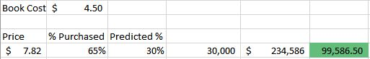

iii. The publisher has agreed to sell you the books at $4.00 each if you sell at least 50,000

When the book is at the lowest cost of $4.00, we can sell the book at the much lower price of $5.95 dollars per book. This pricing will increase the predicted sales percent up to 50 percent. If we meet the predicted sales at 50000 dollars, the predicted revenue will be $29,7607 and profit will be $97,606.79. This is not the most profitable book cost but It is the second most profit out of three predicted values.

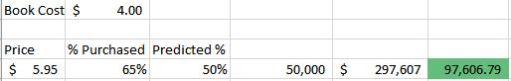

b. Run a constrained optimization for each of the above situations to determine which cost point (from the publisher) and price (to your customer) maximizes your profit. Which cost point should you accept from the publisher?

The price that we would accept from the publisher is $4.50. This price is the most optimal based on the final profit. The book would be sold for $7.82 and we would have to sell at least 30,000 copies to obtain this price from the publisher. We are confident that our predicted sales would be at least 30,000. Accepting this book cost we would generate $99,586.50 in profits.

With the book cost being higher at $5.00 there would not be a specific sales number that is necessary to hit but the profit would still be lower based on the estimated sales of the book. The price of the book would need to be $10.73 and this would generate an estimated 16,580 in predicted sales. This book cost is not one we would consider based on the fact that we would pay a significant amount more with no increased interest in the book.

If the book cost was to be at the lowest end at $4.00, there would again be no gain in taking this offer and this due to the fact that there would be a specific sales number of 50,000 books that would need to be obtained. This would not generate a larger profit because the book price would have to be lowered to $5.95 to hit this sales number.

The best book cost to accept is $4.50. Although other prices seem to be more in favor of the seller and the publisher the best price is based on what all parties are willing to spend and the final profit is maximized at this book cost and the book price of $7.82.

3. Discussion

a. What are the risks of using Harry Potter 7 data in predicting your new demand curve for the Harry Potter sequel?

Most of the assumptions we are making in this analysis is that the sales of Harry Potter 8 (HP8) reflect the sales of Harry Potter 7 (HP7). Therefore, if the sales for Harry Potter 8 are completely different from that of HP7, then this analysis would be inaccurate. For example, if we look at recent history, we can assume that the Cursed Child, the next book that J.K. Rowling wrote about the Harry Potter saga, to be HP8. In this case, everything is different since HP8 is actually written as a play rather than a regular Science Fiction story. Consequently, the audience might not seem as interested in buying the new book even if it is a continuation of the story.

On the other hand, if HP8 turns out to be an even better book than HP7, then we would be losing money. Not the conventional way of losing money by buying more than we can sell, but by not having an optimal return of investment. If HP8 is more popular, then there would be a shift in the demand curve where predicted sales are higher than stated. In this scenario the bookstore should have bought more books since the demand was higher for the book, and they would not have missed out on a greater profit.

The analysis significantly profits on HP7 and HP8 being strongly correlated. To ensure these assumptions are correct, there should be a pre-sale analysis done in order to make the assumptions. Since the end of Voldemort comes on book 7 of the series, the next book will have different villains and maybe even different protagonists. These assumptions should be factored into the analysis. A better way to compare to compute the best sale price for the book can include using the analysis on the other books as well. Has the demand for Harry Potter slowed down? Has it increased exponentially? These are appropriate questions that need answering before we use only the HP7 data when making a Demand Curve analysis.

b. What other data would you like to have to perform your analysis?

There are a couple other variable data sets which could become helpful when performing this analysis. Overall the goal of Book Emporium is to optimize profits and this could be achieved by Harry Potter series sales trends, utilizing other similar book sales, various aspects of timing, and online versus store bought data could be very beneficial to make the most profit as possible.

First, the Harry Potter series was quite successful across the board and could provide a significant amount of data. This data could extrapolate various trends which could then be used to optimize the marketing and sales for the most obtainable profit. Some the trends Book Emporium could seek would be the state of sales over the course of the Harry Potter series. It would be very beneficial to see if the sales have remained steady, increased, or decreased. The book emporium could then use the optimization table to get the most profit by correlating the predicted sales with past sales trends.

The second avenue of data is other similar book sales which could help them predict future sales more accurately. For instance, The How to Train Your Dragon series started in the middle of the Harry Potter series and could be leveraged to see if sales increased in any manner relative to issuance of book seven in the Harry Potter series. Harry Potter was more successful, but studying the demand for similar children’s books in the market at that point in time could help with sales predictions. There may be other economic factors happening at the point in time for this Harry Potter release. The economy may be in recession which could negatively affect demand for the book. These factors would hopefully be shown in data trends for similar book releases in the market. The recession factor relates directly to the third point about timing.

Timing could be a very critical data point for prediction of sales. Looking at the past Harry Potter book releases for seasonality effects would be beneficial to hitting the optimized price point. It would be interesting to see if there is a difference in the winter months versus summer month in sales. One could reason that more people read in winter months when they are typically cooped up inside from the cold weather versus going on vacation in the summer months. We could also check if there is a spike in books during the Christmas period when people are buying presents and have time off school or work to read. A good similarity to draw is the Star Wars movie releases. These movies are typically released in December time frame and have potentially seen an increase in box office sales due to these seasonality factors.

The last data point which would be desired is online sales versus store sales. There is a plethora of online traffic about Harry Potter. Book Emporium could look at past online sales data and correlate with their store sales to see if predicted sales and pricing is in the ballpark. Book Emporium could also look at web traffic to gauge the interest and potential demand for the product. Based on the interest (Costs per Click, Harry Potter related websites visited, geographic location of Book Emporium, search criteria for HP7 release, etc...), Book Emporium could then assign weighted factors to the prediction values and create multiple regression analyses for the sales and optimized profit solutions.

In conclusion, there are many other forms of data which could be used to better perform an optimization analysis. The data from Harry Potter series sales trends, utilizing other similar book sales, various aspects of timing, and online versus store bought data could be critical factors for a good sales campaign. Ultimately, “ capturing data, analyzing information, aggregating and integrating data,” as mentioned in the article Innovating With Analytics1, is key to effectively and successfully getting the best return on the Book Emporium’s investment.

Citation

1Kiron, David, et al. “Innovating With Analytics.” MIT Sloan Management Review, vol. 54, no. 1, 2012, pp. 49–49.